Danielle Child
Pollock, Jackson (1912-1956) Word Count: 1051
Jackson Pollock was one of the leading figures of the Abstract Expressionist movement in mid-twentieth century America. He began his career working for the Federal Arts Project, but is predominantly known for pioneering the ‘drip’ technique in which, using sticks and brushes, the artist dripped paint onto the horizontal canvas. Hans Namuth famously filmed and photographed Pollock painting in 1951. Pollock was the focus of a number of American art critics in the 1950s, particularly of Harold Rosenberg and Clement Greenberg. Although unnamed, Pollock’s method of working was the implicit content of Rosenberg’s ‘The American Action Painters’ (1952) in which the act of painting becomes the central focus of the work. It is Pollock’s canvases that take centre stage in Greenberg’s historicisation of ‘modernist painting’ which followed a formalist trajectory of French painting through to contemporary American painting in the 1950s (this was later expanded in the 1960s to include the ‘high modernist’ painters who develop from Pollock). The attention given to Pollock’s method of painting further fostered the scrutiny of Pollock himself. His subsequent characterisation in popular culture as the manic-depressive who struggled with alcoholism somewhat clouded an understanding of his contribution to modernist painting in later years.
In the 1930s Pollock studied under Thomas Hart Benton at the Arts Student League in New York. Pollock’s early work had many influences; alongside the work of Benton, Pollock drew inspiration from the Mexican muralists – in particular, the scale of the murals - and the work of the North American Indians. In 1935 Pollock started work in the Federal Art Project, initially in the mural division and later moving to the easel painting division. Pollock’s early paintings have spiritual/mythic titles, which refer to ideas of the unconscious, and adopt a totemic imagery (in 1948-52 he abandoned such titles, opting instead to number his paintings). In the 1940s, Pollock adopted the ‘psychic automatism’ of Surrealist writing, developing an automatic painting technique based on this psychoanalysis-inspired process. Alongside William Baziotes and Robert Motherwell, he attended Roberto Matta’s informal workshops during which Matta taught pictorial automatism. However, the automatism of the New York painters differed from that of the Europeans, emphasising the completed work (with which the latter were largely unconcerned). Motherwell termed the Abstract Expressionist technique ‘plastic automatism’ in an attempt to illustrate the distinction between the two. The influence of psychoanalysis in Pollock’s practice can further be traced back to his treatment for alcoholism in 1939, which used the technique of Jungian psychoanalysis.
The role of Pollock’s wife, Less Krasner, also a painter, is often downplayed in narratives of his career; however, Krasner played a key role in introducing him to important figures and techniques. In 1941, Pollock met Krasner while working on a group show curated by the artist John Graham. Krasner introduced Pollock to artists such as Willem de Kooning and Hans Hofmann, and the critics Rosenberg and Greenberg, the latter of whom would play a leading role in Pollock’s popularity among the art elite. In 1942 Motherwell and Baziotes introduced Pollock to Peggy Guggenheim, the then-owner of Art of This Century gallery in New York and wife of Surrealist Max Ernst. In 1943, Art of This Century hosted a solo exhibition for Pollock. As a result of the exhibition, Alfred H. Barr purchased The She Wolf (1943) for the Museum of Modern Art. Greenberg reviewed the show, claiming that Pollock was the greatest painter of his time. Following the success of the exhibition Guggenheim placed Pollock on a retainer of $300 per month. The same year, she commissioned a mural for her town house, which measured eight by twenty feet, providing a scale and technique that would be replicated in the later ‘drip’ paintings.
After marrying in 1945, Pollock and Krasner moved to Long Island where they purchased a farmhouse with five acres of land. It is here that Pollock developed his ‘all-over’ drip paintings, beginning in 1947, in which Pollock abandoned imagery entirely. While painting, Pollock moved physically around and sometimes into the horizontally laid canvas (which collected marks and detritus, such as cigarette butts) leading Allan Kaprow to argue in 1958 that Pollock was ‘in’ his paintings. In 1947, Guggenheim returned to Europe and Betty Parsons became Pollock’s dealer. The drip paintings premiered in Parsons’ gallery in January 1948 and were ridiculed by the general public, but not the art world. In 1949 Pollock graced the cover of Life Magazine with the headline: ‘Is Jackson Pollock the Greatest Living Painter in the United States?’
In his paintings of 1950, the drip paintings grew more condensed with a limited palette. Pollock showed thirty-two such paintings at Parson's Gallery in 1950, including Autumn Rhythm (Number 30) and One (Number 31). The editorial staff of Art News praised the exhibition as one of three outstanding solo shows of the year. Pollock's work was publicized widely (including a Cecil Beaton fashion photo shoot in the exhibition space, later published in Vogue), yet the only painting sold from the show was Number 1(Lavender Mist) (1950). The same year Hans Namuth approached Pollock to ask to film him working. As a result 500 photos and two films (one black and white and one colour) were produced in 1951. The films and photographs produced by Namuth were central to the characterization of Pollock as an expressive, performative painter who is inseparable from his paintings. Pollock’s spoken narrative within the film affirms these ideas.
From 1954-55 Pollock virtually abandoned painting; he drank heavily and suffered from depression. As if already predicting his demise, Greenberg used the past tense to refer to Pollock in his 1955 essay, ‘American-type Painting’, stating: ‘…he went beyond late Cubism in the end.’ Despite this, there was still public interest in his work, marked by Time Magazine’s 1956 ‘Jack the Dripper’ piece. On 10 August 1956, Pollock drove his car off the road whilst under the influence of alcohol, killing himself and Edith Metzger, one of the two passengers in the car.
References and further reading
Greenberg, C. (1955) ‘American-Type Painting’, reprinted in Frascina and Harris (1982), eds, Modern Art and Modernism, London: Harper & Row, pp.5-10.
--- (1960) ‘Modernist Painting’, in Frascina and Harris (1982), pp.93- 104.
Kaprow, A. (1958) ‘The Legacy of Jackson Pollock’, Art News, 57 (6): 24-26, 55-57.
Leja, M. (1993), Reframing Abstract Expressionism: Subjectivity and Painting in the 1940s, New Haven: Yale University.
Orton, F. and G. Pollock (1996), ‘Jackson Pollock, Painting and the Myth of Photography’ in Avant-Gardes and Partisans Reviewed, Manchester: Manchester University.
Rosenberg, H. (1952), ‘The American Action Painters’, Art News, 51(8): 22-3, 48-50.

Images
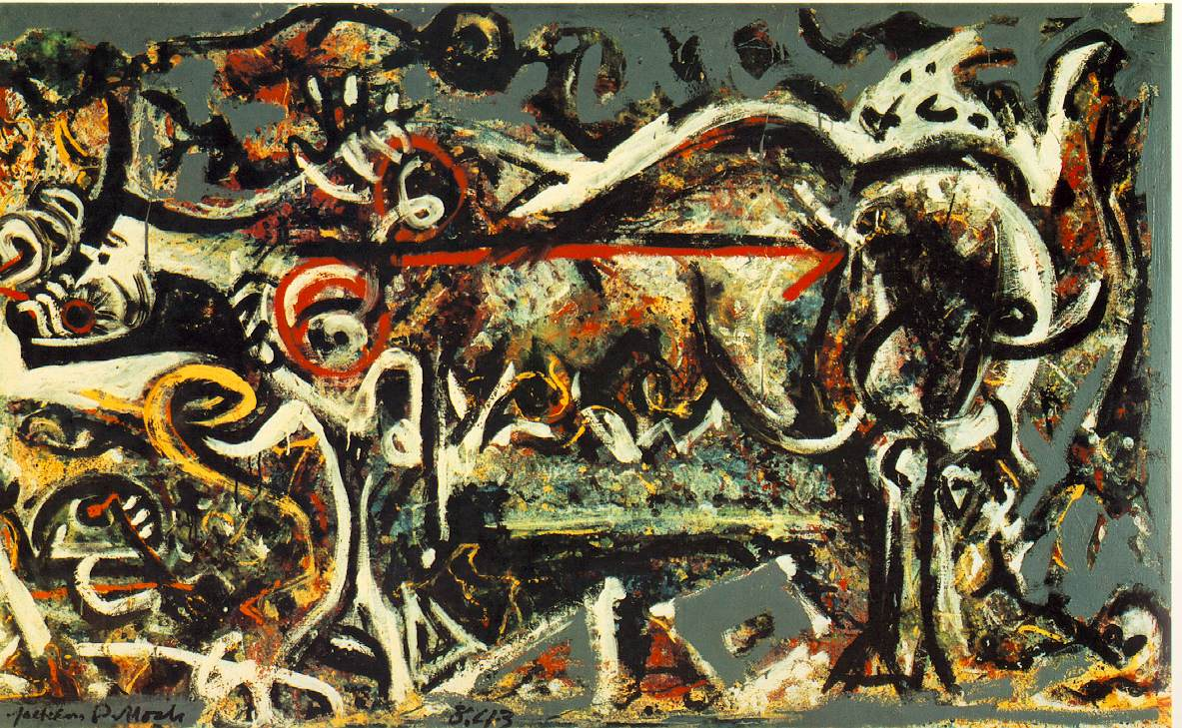
The She-Wolf 1943 (230 Kb); Oil, gouache, and plaster on canvas, 41 7/8 x 67 in; The Museum of Modern Art, New York. http://www.ibiblio.org/wm/paint/auth/pollock/pollock.she-wolf.jpg

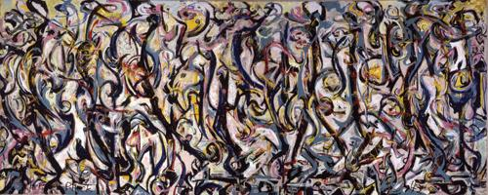
Mural, 1943
97 1/4 x 238 in (247 x 605 cm)
Gift of Peggy Guggenheim, 1959.6, University of Iowa Museum of Art.
http://uima.uiowa.edu/mural/

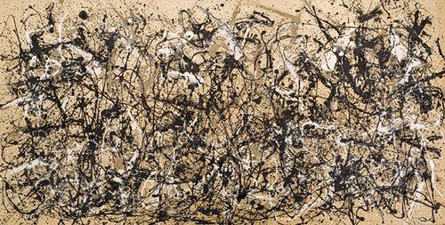
Autumn Rhythm (Number 30), 1950
Enamel on canvas; 105 x 207 in. (266.7 x 525.8 cm)
George A. Hearn Fund, 1957 (57.92)
© 2011 The Pollock–Krasner Foundation / Artists Rights Society (ARS), New York
http://www.metmuseum.org/toah/images/h2/h2_57.92.jpg

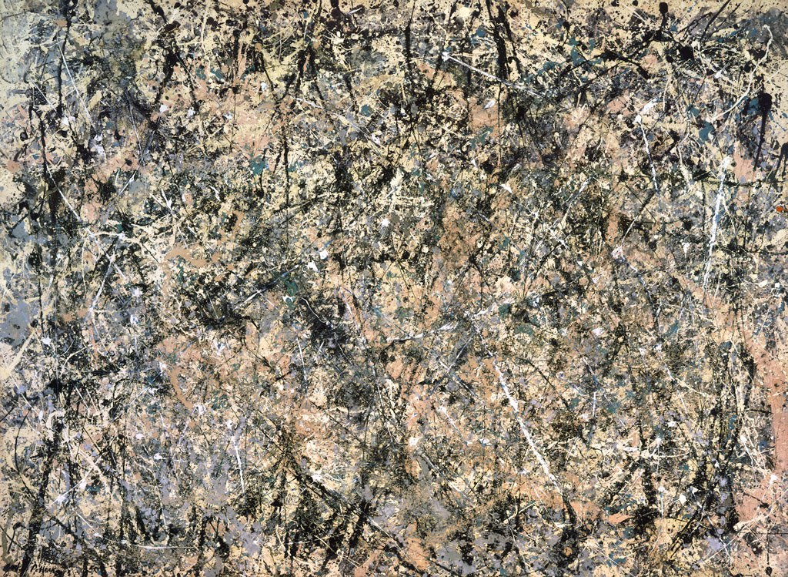
Jackson Pollock, Number 1, 1950 (Lavender Mist),1950, National Gallery of Art, Ailsa Mellon Bruce Fund, 1976.37.1 https://www.nga.gov/feature/pollock/lm1024.jpg

